**Lab 10.2**

*Nama/NIM : Marsa Kristian/21410100021*

Insert

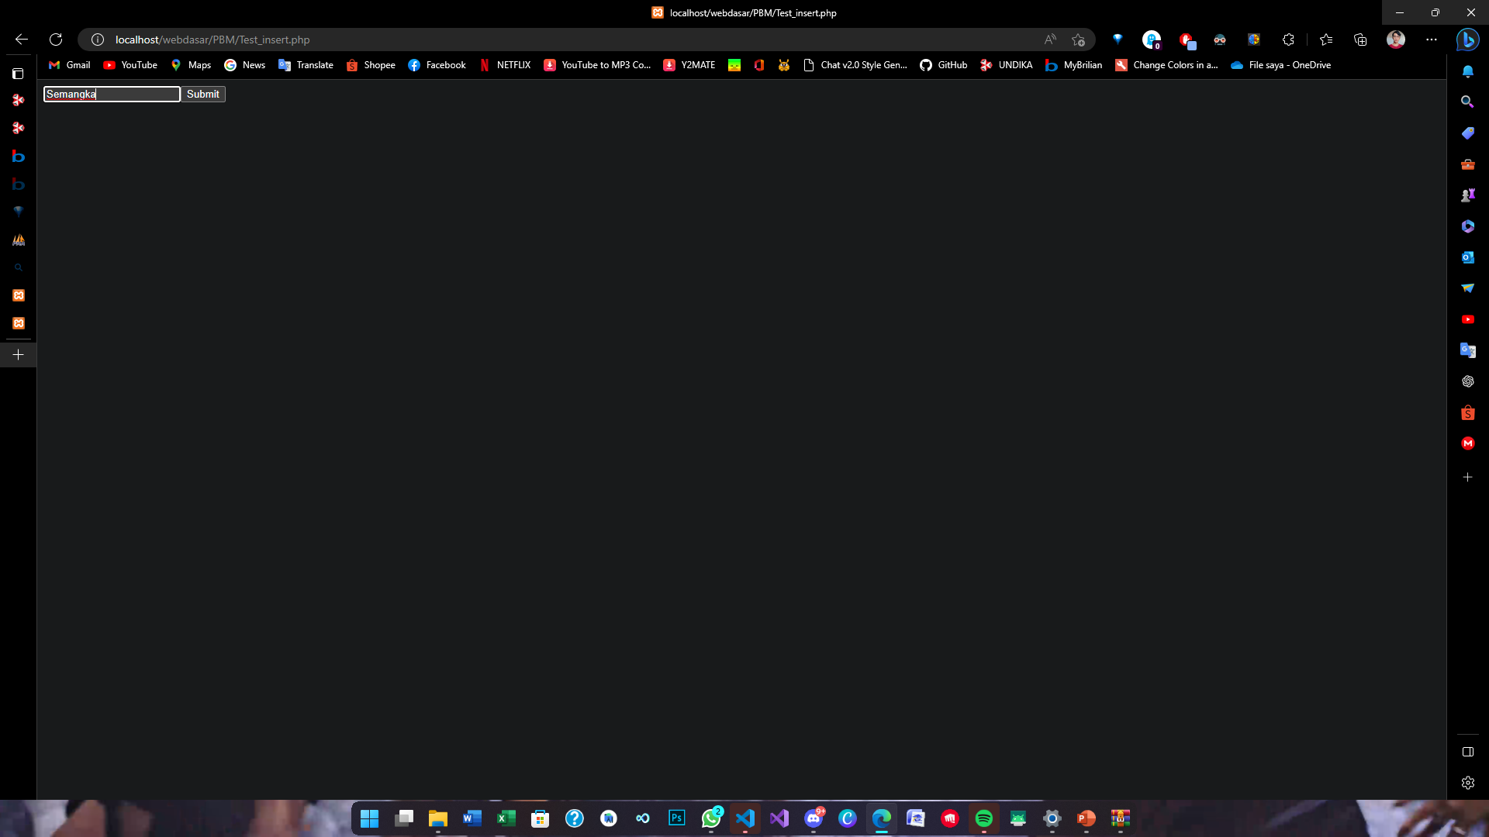

<?PHP

echo "<FORM METHOD='POST' ACTION='take_order.php'>";

echo "<INPUT TYPE='TEXT' id='item_name' name='item_name'>";

echo "<input type='submit'>";

echo "</FORM>";

?>

Order

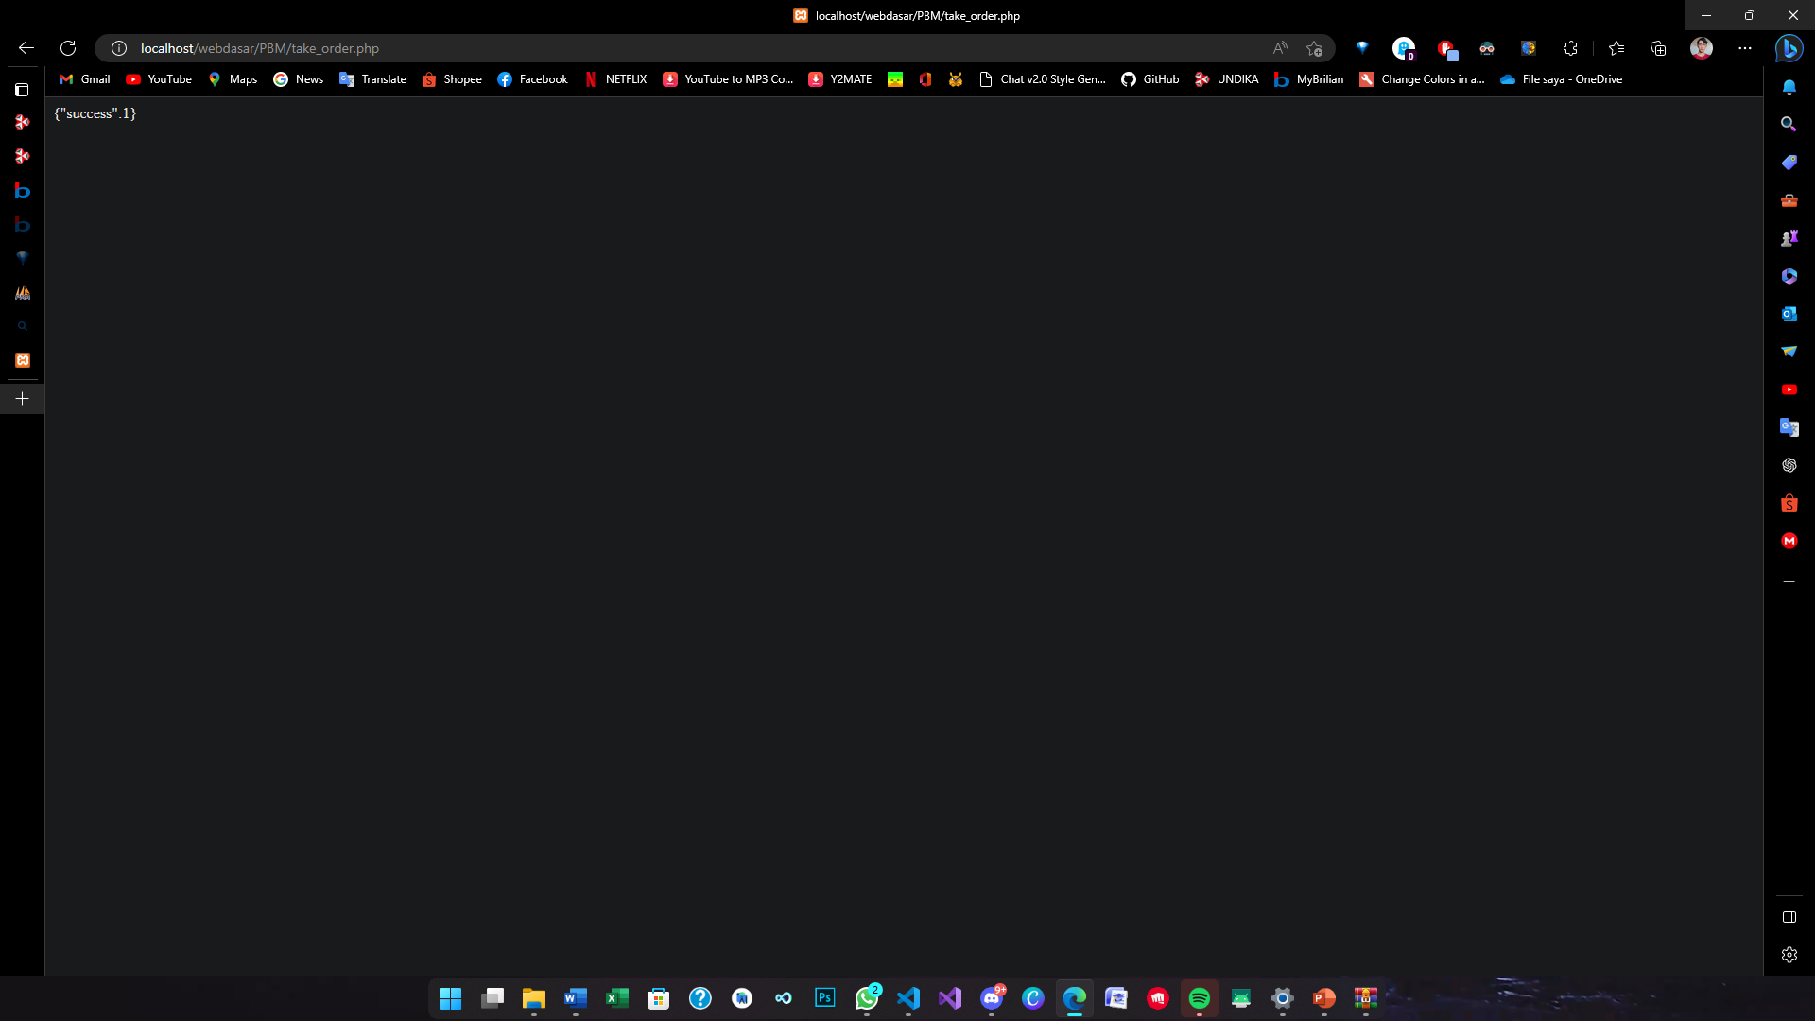

<?php

error_reporting (0);

include ("Db_config.php");

// array for JSON response

$response = array();

if(!(empty($_POST['item_name'])))

{

  $item_name=$_POST['item_name'];

  //echo $item_name;

  $result = mysqli_query($db, "INSERT INTO myorder_210021(Item) VALUES ('$item_name')");

  if ($result > 0) {

  $response["success"] = 1;

  }

  else{

  $response["success"] = 0;

  }

  // echoing JSON response

  echo json_encode ($response);

}

//else{

  //echo "Kosong";

//}

?>

View

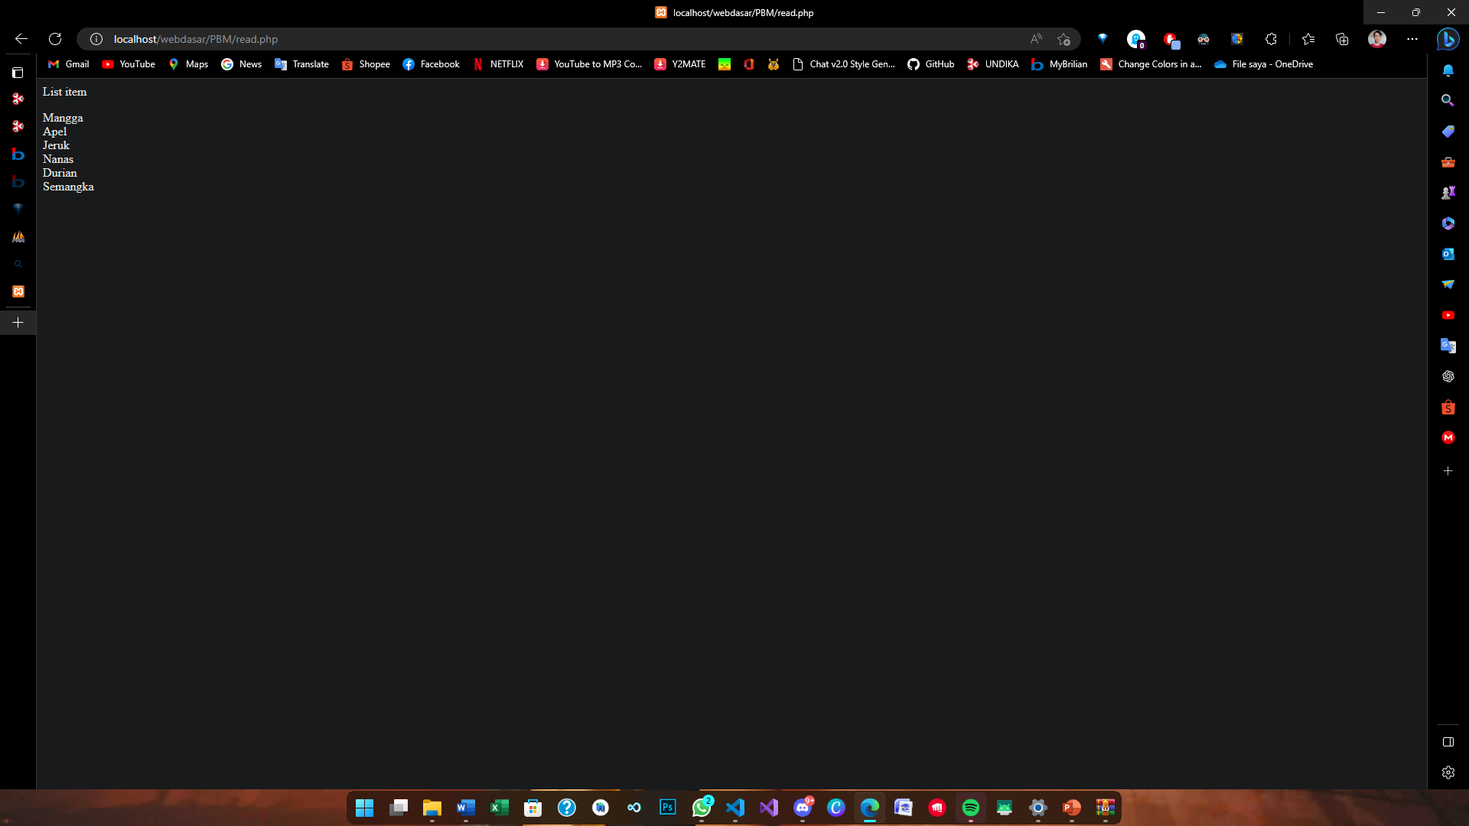

<?php

include 'Db_config.php';

$sql = "select * from myorder_210021";

$hasil =  mysqli_query($db,$sql);

//cek akses table

//print_r($hasil);

echo '<p>List item</p>';

if(mysqli_num_rows($hasil)>0)

{

    while($isi=mysqli_fetch_assoc($hasil))

    {

        echo $isi["Item"];

        echo '<br>';

    }

}

?>